## General Considerations:

# BCHC Youth Activities Policy

POLICY# 1018-2a APPROVED 10/13/18

Policy Amended - 10/12/19

Policy Amended – 10/8/22

## Youth participating in BCHC events must be members at the time of the event.

1. Helmets must be worn by all 17 and under youth any time they are mounted.
2. Utilize teachers, 4-H leaders, church group leaders and others who have experience working with youth as teachers and/or chaperones.
3. The nature of the youth activity determines the maximum number of youth participants. If riding on the trail, youth group size should not exceed 10. On the trail, there should be a minimum of 3 adult chaperones accompanying the youth group. In campground and other areas, the ratio of youth to chaperones should be a minimum of 4:1.
4. If youth group is of mixed gender, always have chaperones of both genders present.
5. Create a detailed schedule. Keep participants busy; don't allow too much "free time". Education topics may involve Leave No Trace, packing skills, basic care of horse/mule, care & maintenance of tack & equipment, etc. Select age appropriate topics and focus on safety.
6. **It is mandatory** *that members as defined in the Background Check Requirement Policy 1019-1 obtain a BCHC Youth Volunteer Program Card and* possess *the California mandate reporter certificate. To obtain the certificate go to* [*http://mandatedreportercaltraininglvolunteers.*](http://mandatedreportercaltraininglvolunteers/) *To receive the youth program card you must submit for the fingerprint and background check clearance. Contact the BCHC Custodian of Records (COR) by email for information. If you violate any part of this youth policy your card will be revoked. Sponsoring Unit will determine who pays for fingerprinting* & *background check.*

# Background Check Approval Process:

Background checks will be considered approved if applicant meets the following criteria as determined by the BCHC-COR:

1. Is not now on Megan's Law list
2. Is not a registered Sex Offender
3. Has not had a conviction for Domestic Violence in the last 5 years Penal codes are attached.



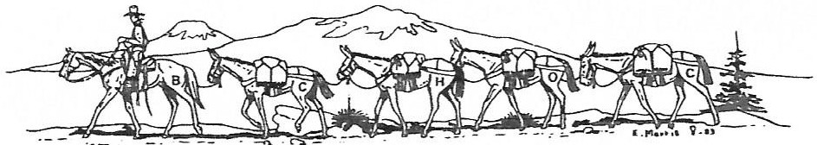

Backcountry Horsemen of California

# Applying for a Youth Volunteer Program Card

Applying for your Youth Volunteer Program card instructions:

* 1. Print the BCIA 8016 Live Scan Application form. (Available from the BCHC website only:

[**http://bchcalifornia.org/youth.htm.)**](http://bchcalifornia.org/youth.htm.))

* 1. Fill out Applicant information section only.
  2. Go to **https://oag.ca.gov/fingerprints/locations** for the nearest live scan location near you. (Applicant is responsible for live scan fees.)
  3. After completing the fingerprinting process, email your name, unit, mailing address (if different than one submitted on application), application date and ATI number (located at the bottom of the live scan application form) to [bchc_cor@yahoo.com.](mailto:bchc_cor@yahoo.com) Allow 7-21 days for a US mail response.
  4. Obtain the California mandated reporter certificate by completing the online coarse at http://jmandatedreporterca/training/volunteers and submit the certificate number to the Youth Education VP

If you have any question regarding the background check process **prior** to submitting, you may contact the BCHC COR by email [bchc_cor@yahoo.com.](mailto:bchc_cor@yahoo.com) Once the request for the report has been submitted the COR cannot communicate any information regarding the content of the report, as per State law.